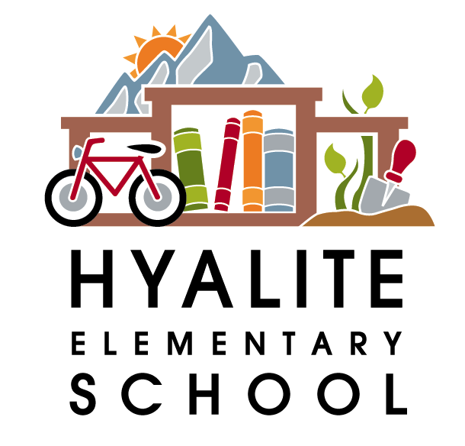 The Hyalite Highlights—February 2nd, 2017

Dates to Remember:
February 7th— PAC meeting from 6-7:30pm in the library—Pizza and childcare for the kids
February 10th—Lip Sync for Literacy—6:30pm at the Ellen Theatre—see below for details
February 14th-16th—Snowshoe Days in gym class—more details will come home
Feb. 20th—President’s Day—No School
March 11th-19th—Spring Break—No School
April 6th & 7th—PIR Days—No school
May 26th—PIR Day—No School
May 29th—Memorial Day—No School
June 8th—Last Day of school—students dismissed at 12:45

Lip Sync for Literacy
February 10th, 6:30pm at the Ellen Theatre
Come watch Hyalite teachers battle the Irving staff in an evening of lip sync fun! Your donations will decide the winner! There will be a silent auction, complimentary dessert table, cash bar and more. Tickets start at $6.50/person and are on sale at www.theellentheatre.com. Proceeds from the FUNdraiser will be divided evenly between the schools for purchasing books! For more information: www.hyalitepac.org/lipsync. If you can make a donation of a silent auction item, please contact Jodi at aboutfamilies@yahoo.com
6th Grade Registration
SMS and CJMS will be hosting registration/parent nights at their schools, to get your 5th graders ready for Middle School. SMS’s will be a parents only night February 16th from 6-7:30 pm. and CJMS’ will be for parents and students from 6-7:30 pm on Feb. 16th. If you have questions, please call Sally Owen (SMS) at 522-6422 or Brian Mitchell (CJMS) at 522-6321. Please make sure and attend the Parent night at the school where your child is zoned to go. If you are not sure which school that is, please call Sandi Chamberlain in our enrollment office at 522-6005. Hope to see you there.
NEW STUDENT/KINDERGARTEN REGISTRATION FOR 2017-2018

The 1st round of enrollment for new student and kindergarten registration for grades K-5 will be from Monday, March 6th, through Monday, April 10th. Beginning March 6th, enrollment forms may be downloaded off the district website, www.bsd7.org, or enrollment packets may be picked up at the enrollment office at Willson School.

All students NEW to the Bozeman School District, including all KINDERGARTEN students must complete and return registration forms along with current immunization records and birth certificate to the Enrollment Office at 404 West Main during the registration period. Any questions, please call Sandi Chamberlain at 522-6005.

